Software Requirements Specification

for

Hospital ER Simulation

Prepared by

Group Name: Medical Software

|  |
| --- |
| Ancel Carson |
| Robert Zebe |

|  |  |
| --- | --- |
| Instructor: | Mr. Doug Lim |
| Course: | COSC3403-Software Engineering 1 |
| Version: | 1.0.0 |
| Date: | February 20, 2019 |

Table of Contents

Table of Contents ii

1 Introduction 1

1.1 Document Purpose 1

1.2 Product Scope 1

1.3 Definitions, Acronyms and Abbreviations 1

1.4 References and Acknowledgments 1

2 Overall Description 2

2.1 Product Functionality 2

2.2 End Users and Characteristics 2

2.3 System Stakeholders 2

2.4 Operating Environment 2

3 Specific Requirements 3

3.1 User Interface 3

3.2 Functional Requirements 3

3.3 Use Case Diagram 4

4 Non-functional Requirements 5

4.1 Software Quality Attributes 5

Appendix A - Group Log 6

# Introduction

This project will give Doctors and Nurses the ability to simulate a work shift for their Emergency Room location. This can help the ER facility to decide how to allocate personnel. This section will include details on the purpose of the project, information about the project’s scope, some acronyms/abbreviations, and references.

## Document Purpose

This document is to illustrate the purpose, scope, functionality, requirements and other attributes of the Hospital ER Simulation software being developed by the Medical Software team. This is the first revision of this document and pertains to the initial release of the Hospital ER Simulation software. This software will benefit ER personnel by giving them some idea of how well their facility can operate under a certain patient inflow.

## Product Scope

The scope of this project is to create a generic software simulation tool that can be easily modified to the specifics of a particular ER facility. This is to be a fully functioning system not requiring outside assistance with the exception of user input. The software will have a graphical simulation option and an alternative that quickly output the same information.

## Definitions, Acronyms and Abbreviations

Patient Severity: The specific interpretation of these ratings (1-4) are up to the ER facility; however, a patient with a rating 1 is probably has a cold or a something minor while a rating 4 is life or death.

## References and Acknowledgments

Dr. Rouse’s 2018 Data Structures Class

# Overall Description

## Product Functionality

1. Can be tailored to the trends at the user’s location
2. Quickly give the results for a given shift length
3. Output meaningful data

## End Users and Characteristics

End Users:

1. Doctors
   1. Not Familiar with Computer Science
2. Nurses
   1. Not Familiar with Computer Science
3. ER facilities
   1. Require money to operate
   2. High necessity of optimization/efficiency
4. Hospitals
   1. Require money to operate
   2. High necessity of optimization/efficiency

## System Stakeholders

Ancel Carson and Robert Zebe (Student Programmers)

Doug Lim (Professor)

## Operating Environment

This system will need to function on a computer being used in an ER Facility. Traditionally these are older models of computers and typically have significantly slower processing speeds. The aim of the project is to make the program work on a Windows 10 operating system, but older Windows operating systems should still be able to run the program. This program must be able to run while any other necessary medical application is also running.

# Specific Requirements

## User Interface

Starting Panel:

This panel displays all the setting of the program that can be modified by the user. The user will need to check the boxes for which data field they would like to modify. This is to reduce the chance of accidentally changing a value. At the bottom are three buttons that will either bring up the help panel or start the timed or instantaneous simulation.

Help Panel:

This panel will explain difficult to understand verbiage and explain how to operate the program.

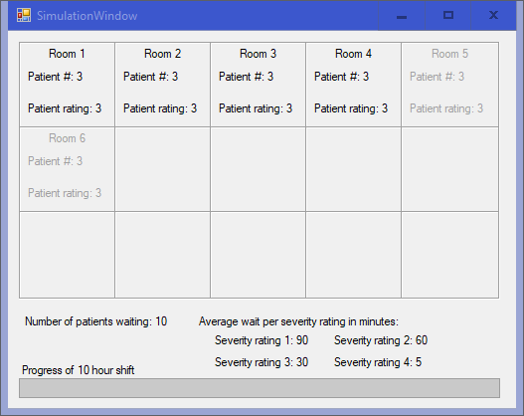

Timed Simulation Panel:

This panel will only appear if the “Timed Simulation” option is chosen. This panel consists of several boxes containing room number, patient number, and severity of the patient’s condition. Below the boxes are the number of patients currently waiting and average wait times for patients based on severity. The bottom of the panel is a progress bar to help the user gauge how much time is left.

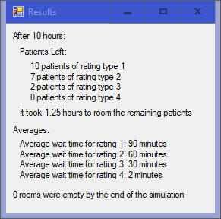

Results Panel:

This will appear either after the Timed simulation has completed or after the instantaneous option Is chosen on the starting panel (if the instantaneous simulation has a delay a window will pop up telling the user that the calculation is in progress). This panel shows how many patients of each severity are left after the shift and how much time would be needed to tend to those patients. It also displays average wait times for each severity throughout the simulation.

## Functional Requirements

User Interface Requirements

1. Ease of understanding and simplistic design
   1. Simple wording
   2. Help button for clarification
2. Ability to change values to be simulated
   1. Delay between patients arriving
   2. Number of availably rooms
   3. Percent chance per patient type
   4. Time in room per patient type
3. Multiple simulation methods
   1. Times simulation
      1. Shows flow of patients in and out of rooms
   2. Instant simulation
      1. Quickly runs calculations to give results

Simulation Requirements

1. Patient generation
   1. Individual values per patient
   2. Generated when “enter” waiting room
2. Multiple instances
   1. Allow for different simulations to be compared
   2. Prevent data crossover
3. Real time statistics
   1. Display useful data during simulation
      1. Average wait times
      2. Number of patients
4. Comprehensive results
   1. Display useful data once simulation has completed
      1. Average wait times
      2. Number of patients
      3. Patients waiting after 10 hours
      4. Values given at the start of the simulation

Code Requirements

1. Well documented
2. Consistent format
3. Simplicity

## Use Case Diagram

Click Help Button

If Timed

User

If Instant

# Non-functional Requirements

## Software Quality Attributes

All interfaces in English

Work on the windows 10 operating system

Be coded in C#

Not crash when program is being used as intended

Timed simulation to last 10 minutes

Instantaneous simulation to take no more than 30 seconds on laptop from 2016

Under 100 GB of space

Appendix A - Group Log

|  |  |  |  |  |  |
| --- | --- | --- | --- | --- | --- |
| Name\Hours | Coding | Meetings | Reports | Presentations | Overhead |
| Ancel Carson | 5 | 2 | 2 | 1 | 0 |
| Robert Zebe | 3 | 2 | 4 | 1 | 0 |